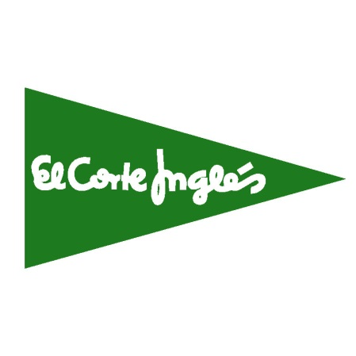
Nombre: ___________________________________
Clase: __________ Fecha: ____________________
¡Vamos de compras!

Complete the following worksheet using the website www.elcorteingles.es.The website is entirely in Spanish, so use pictures and context clues to help you.

Parte A: Explorar

Explore the website for El Corte Inglés to answer the following questions.
- How would you describe the store? Is it small or large? What are some of the different products you can buy here?
_____________________________________________________________________________________________________________________________________________________________________________________________________________________________________________________________________

- Would this be a store you would be interested in shopping at? Why or why not?
_____________________________________________________________________________________________________________________________________________________________________________________________________________________________________________________________________

- Which U.S. store do you think El Corte Inglés is the most similar to? Why? (Think about the products they sell as well as the prices.)
_____________________________________________________________________________________________________________________________________________________________________________________________________________________________________________________________________

Parte B: la ropa

Find a picture of two clothing models on the website- one male and one female. In Spanish, describe what they are wearing using your clothing and colors vocabulary and complete sentences en español. Be sure to watch noun-adjective agreement!

El hombre:

La mujer:

Parte C: Situación
You are an exchange student in Madrid and you will be attending a formal party this weekend for your host family’s grandparent’s 40th wedding anniversary. You did not pack a lot of formal clothes and need to buy something appropriate to wear for the fiesta, including accessories and shoes. (Hint: the word “moda” will lead you to the clothing section.) You have $150 USD to spend on your new outfit. In the left column, write the type of clothing item (artículo) you are buying. In the middle column, write the brand name (marca) of the clothing. Then, list the price of the clothing in both euros and U.S. dollars. Be sure to use the correct exchange rate and DO NOT go over your budget!

Exchange rate: ________ euros = 1 USD

Artículo Marca Euros Dólares
_________________________ _________________________ __________ __________
_________________________ _________________________ __________ __________
_________________________ _________________________ __________ __________
_________________________ _________________________ __________ __________
_________________________ _________________________ __________ __________
_________________________ _________________________ __________ __________
_________________________ _________________________ __________ __________

Totales: __________ __________

Parte D: vocabulario nuevo

Write down at least 5 new vocabulary words you learned as well as 2 new phrases you saw while you were shopping online at El Corte Inglés. Next to these words/phrases, write what you believe the meaning is based on context clues.

Palabra nueva | El significado

Frase nueva | El significado

