Ecuador Andes and Amazon Adventure Tour 2018
Flight and Hotel Information

You must arrive at the airport by 10:30am on Saturday, March 31!

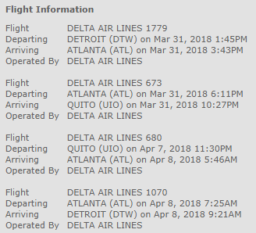

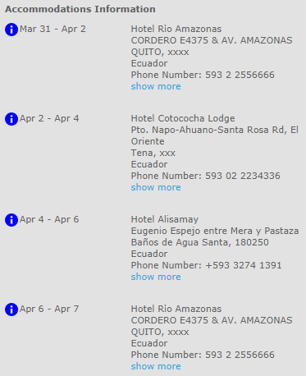
Explorica 24 Hour Emergency Line (617) 210-6194

