**Apuntes 1.4: ¿Qué hora es?**

**Descubre 1 vtext pgs. 24-25**

el mediodía = _________________________ la medianoche = __________________________

en punto = _________________________ y cuarto = ______________________________

y media = __________________________ menos cuarto = _________________________

When talking about a specific time in Spanish, use the following:

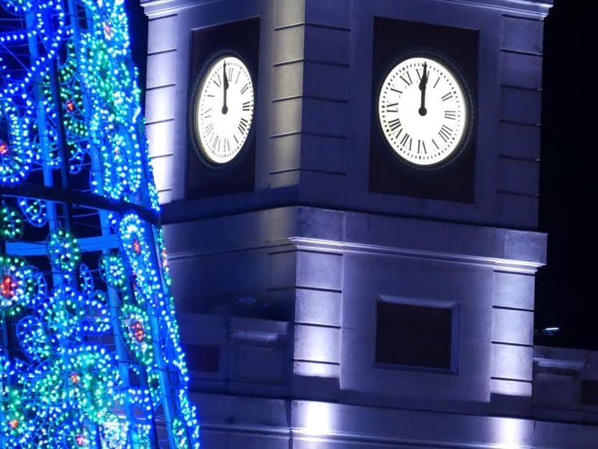

de la mañana = ________________________

de la tarde = __________________________

de la noche = _________________________

When no specific time is mentioned, use the expressions:

por la mañana = ________________________

por la tarde = ________________________

por la noche = _________________________

To tell time in Spanish, use the following:

**Es… Son…**

**Es la una.** It is one o’clock. **Son las dos.** It is two o’clock.

**Es la medianoche.** It is midnight. **Son las (tres-doce).** (3:00-12:00)

**Es el mediodía.** It is noon.

When telling time when the minutes are between :01 and :29, use the following formulas:

1:00-1:30 ONLY- **Es + la + (hora) + y + (minutos).**

**Son + las + (hora) + y + (minutos).**

When telling time and the minutes are between :31 and :59, use the following formulas:

12:30-1:00 ONLY- **Es + la + (next hora) + menos + (minutos).**

**Son + las + (next hora) + menos + (minutos).**

Be careful to distinguish *what* time it is and *at* what time something occurs.

**¿Qué hora es? ______________________________**

**Son las dos y cuarto. ______________________________**

**¿A qué hora es la clase? ______________________________**

**A las dos y media. ______________________________**

Many bus, train, plane, theater and museum schedules use a 24-hour clock, like military time. After 12 noon, the hours are **13,00 h.** through **24,00 h.**

15,00 h. = __________________ 20,30 h. = ______________________

**Ejemplos:**

1:35 7:25

9:15 12:30

**Práctica:**

8:10 pm ______________________________________________________________________________

3:45 am ______________________________________________________________________________

6:15 am ______________________________________________________________________________

1:55 pm ______________________________________________________________________________

11:40 pm ______________________________________________________________________________

12:00 am ______________________________________________________________________________